

**Online learning**

**Software Design Specification**

– Hanoi, May 2023 –

Record of changeS

|  |  |  |  |
| --- | --- | --- | --- |
| Date | A* M, D | In charge | Change Description |
| 15/5/2023 | A | Manh | Added Screen Details |
|  |  |  |  |
|  |  |  |  |
|  |  |  |  |
|  |  |  |  |
|  |  |  |  |
|  |  |  |  |
|  |  |  |  |
|  |  |  |  |
|  |  |  |  |
|  |  |  |  |
|  |  |  |  |
|  |  |  |  |

*A - Added M - Modified D - Deleted

**Table of Contents**

I. Overview 4

1. Code Packages 4

2. Database Design 4

a. Database Schema 4

b. Table Description 4

II. Code Designs 5

1. <Feature/Function Name1> 5

a. Class Diagram 5

b. Class Specifications 5

c. Sequence Diagram(s) 5

d. Database queries 6

2. <Feature/Function Name2> 6

# I. Overview

## 1. Code Packages

*[Provide the package diagram for each sub-system. The content of this section including the overall package diagram, the explanation, package and class naming conventions in each package. Please see the sample & description table format below (****please note: package names don’t follow Java package naming convention yet****)]*

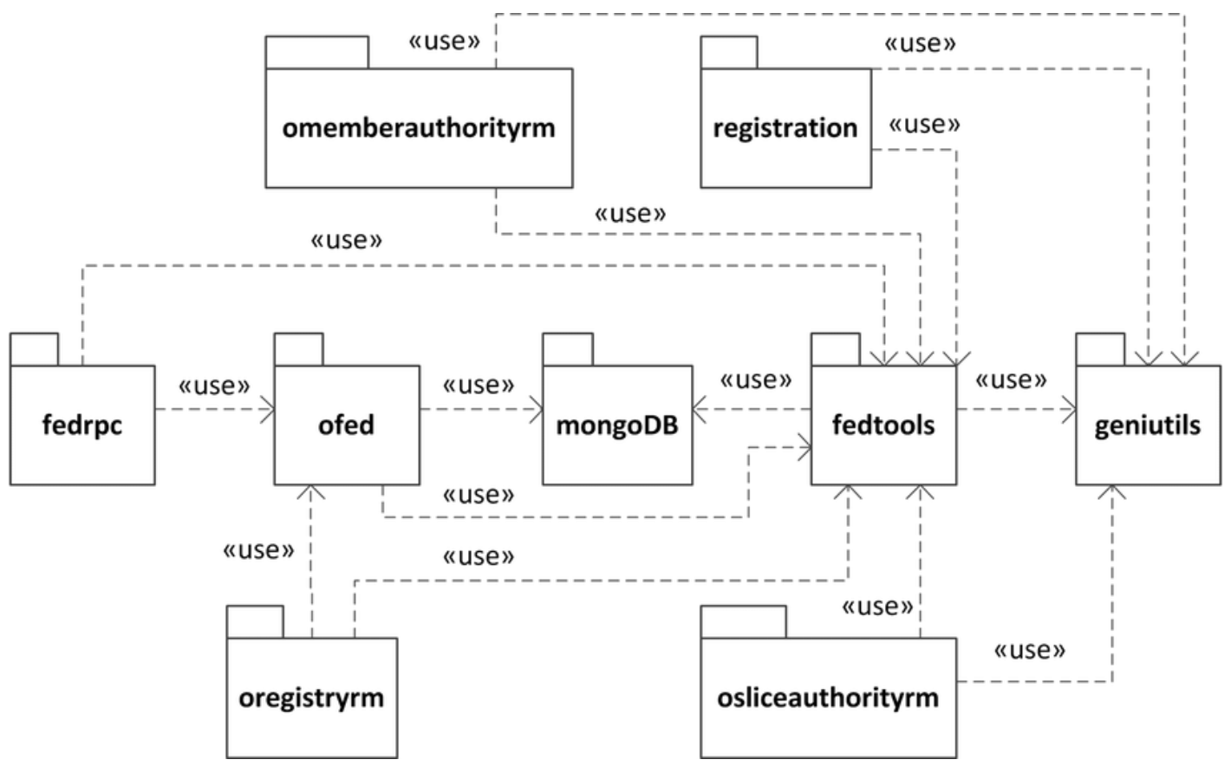

***Package descriptions***

|  |  |  |
| --- | --- | --- |
| **No** | **Package** | **Description** |
| *01* | *omemberauthorityrm* | *<Description of the package>* |
| *02* | *registration* | *<Description of the package>* |
| *03* | *fedrpc* | *<Description of the package>* |
| *04* | *ofed* | *<Description of the package>* |
| *05* | *mongoDB* | *<Description of the package>* |
| *06* | *fedtools* | *<Description of the package>* |
| *07* | *…* |  |

## 2. Database Design

### a. Database Schema

*[Provide the tables relationship like example below – following MySQL database naming convention]*

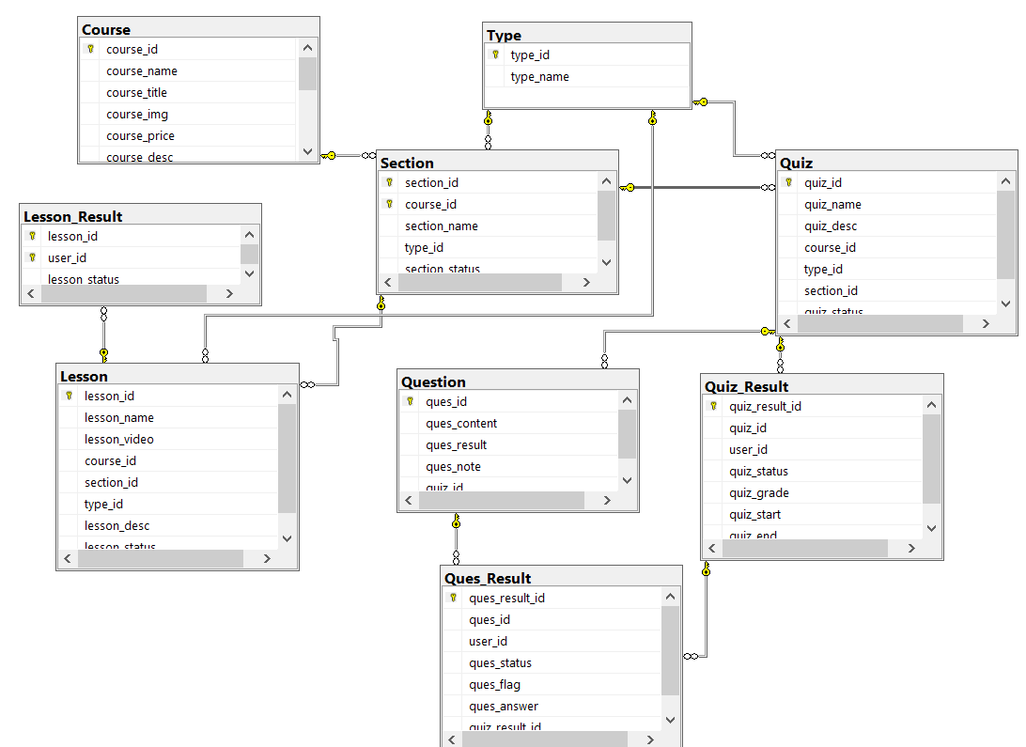

### b. Table Description

|  |  |  |
| --- | --- | --- |
| **No** | **Table** | **Description** |
| *01* | *Quiz* | The "quiz" table is used to store information about the tests in the system. The data fields in the table allow you to define and manage the |
| *02* | *Course* | The "Course" table stores information about individual courses within the system. Each course is identified by a unique course ID and has a name, title, image, price, and description associated with it. |
| *03* | *Type* | The "Type" table is used to store information about different types or categories within the system |
| *04* | *Question* | The "Question" table is used to store information about individual questions within the system. Each question is identified by a unique question ID and has associated content or text that represents the actual question being asked |
| *05* | *Lesson* | The "Lesson" table is used to store information about individual lessons within the system. Each lesson is identified by a unique lesson ID and has a corresponding name or title. |
| *06* | *Lesson_Result* | The "Lesson_result" table is used to store information about the results or progress of users in completing lessons. |
| *07* | *Section* | The "Section" table is used to organize and manage different sections within a course. Each section is identified by a unique section ID and is associated with a specific course using its course ID. |
| *08* | *Quiz_Result* | The "Quiz_Result" table is used to store information about the results and performance of users in quizzes |
| *09* | *Ques-Result* | The "Quiz_Result" table is used to store information about the results and performance of users in quizzes |

# II. Code Designs

## 1. <Feature/Function Name1>

*[Provide the detailed design for the function <Feature/Function Name1>. It include Class Diagram, Class Specifications, and Sequence Diagram(s)]*

### a. Class Diagram

*[This part presents the class diagram for the relevant feature]*

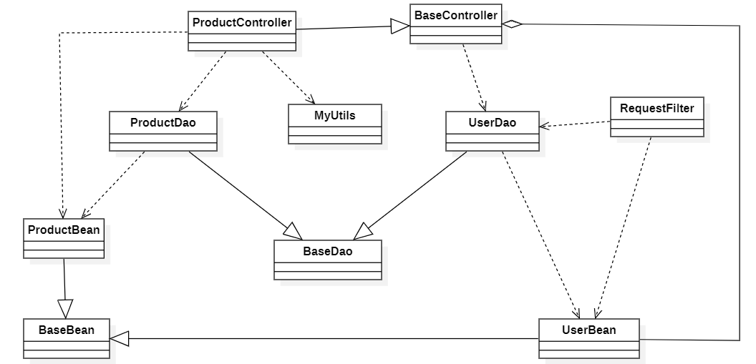

### b. Class Specifications

*[Provide the description for each class and the methods in each class, following the table format as below]*

#### XYZ Class

*[Provide the detailed description for the class methods]*

|  |  |  |
| --- | --- | --- |
| **No** | **Method** | **Description** |
| *01* | *<method name>* | *<Description of the method, including the inputs, outputs & internal method processing>* |
|  |  |  |

#### ABC Class

***Class Methods***

*[Provide the detailed description for the class methods]*

|  |  |  |
| --- | --- | --- |
| **No** | **Method** | **Description** |
| *01* | *<method name>* | *<Description of the method, including the inputs, outputs & internal method processing>* |
|  |  |  |

### c. Sequence Diagram(s)

*[Provide the sequence diagram(s) for the feature, see the sample below]*

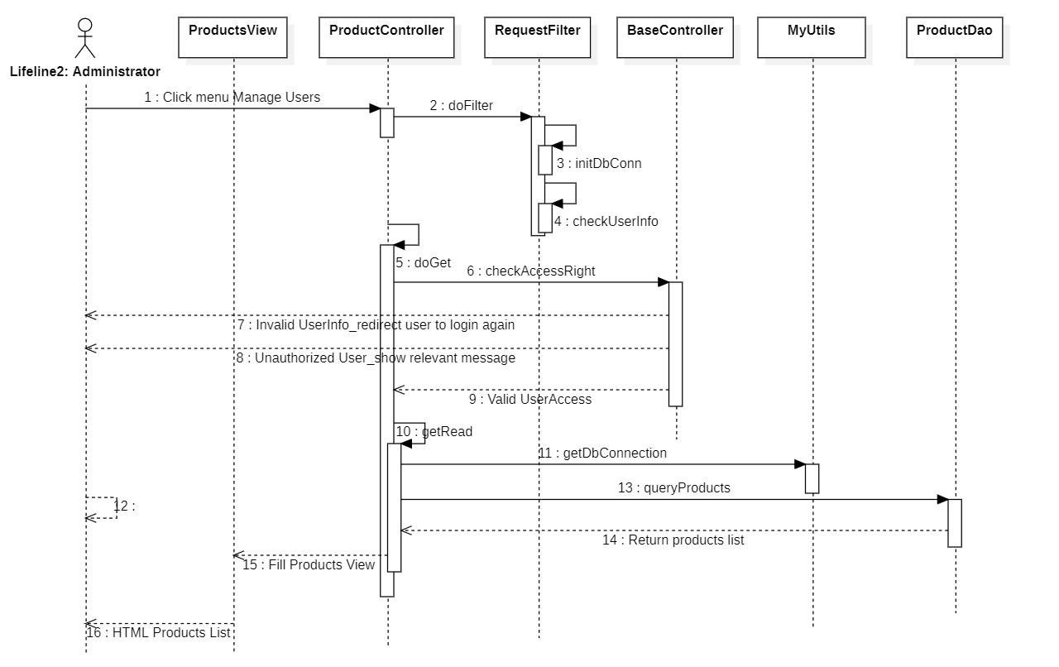

### d. Database Queries

*[Provide the detailed SQL (select, insert, update...) which are used in implementing the function/screen]*

## 2. <Feature/Function Name2>

…